**3. TO DEVELOP INTERACTIVE WEB GIS MAP IN CHOLERA OUTBREAK MANAGEMENT**

The web GIS system has been developed based on open source applications will provide resourceful means for decision making in cholera outbreak management. The distributed web GIS allows for any user with internet connectivity to access the mapping services on the World Wide Web. The platform shows its potential in cholera information sharing to both GIS and non GIS health. The application is accessible through a generic web browser at: [*https://maxwell0401.github.io/CholeraSpatialEpidemiology*](https://maxwell0401.github.io/CholeraSpatialEpidemiology).

The User Interface (UI) contains tabs such home, gap, objective, results, map and downloads. On the extreme left the interface shows widgets such as zoom in, zoom out, zoom to extent and a tool for measuring distance and area. The top right of the interface shows spatial layer for cholera case, water source and pit latrine. By clicking the mark symbol on the right of each layer, the respective layer in the map window is removed. The interface has also cartographic elements such as legend and scale. The ‘LEGEND’ section shows the symbols and colors used in the map. Figure 1 shows the user interface for the developed web GIS.

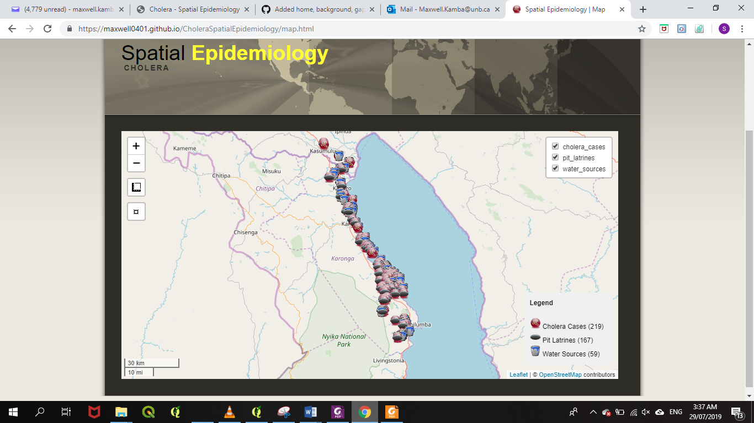

**Figure 1: User Interface for the interactive web GIS**

The developed web GIS interface allows users to download data and share it in different file formats such shape-file, KML, excel and others.

The developed web GIS can be accessed remotely on a mobile device. Any mobile device can access it remotely as long as the device has internet connectivity; this is through the IP address. Users can access the application from mobile devices such as tablets and smartphones to access the same services just like those who are accessing the same from a personal computer or laptop. Figure 2 shows the interactive web GIS accessed using the mobile phone.

